Ray
# Source: AI Source: Provided by: [Data Path: Persons Table -> ID Column: 1, Name_En Column: Motasem Essam] -> From: [ChatGPT] on [7/25/2026]
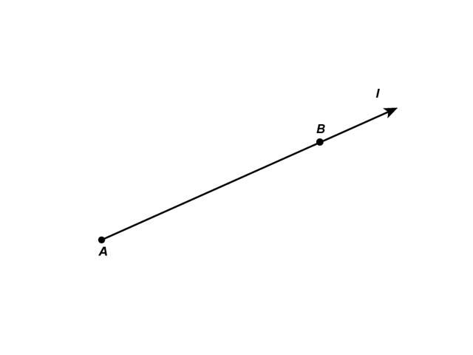
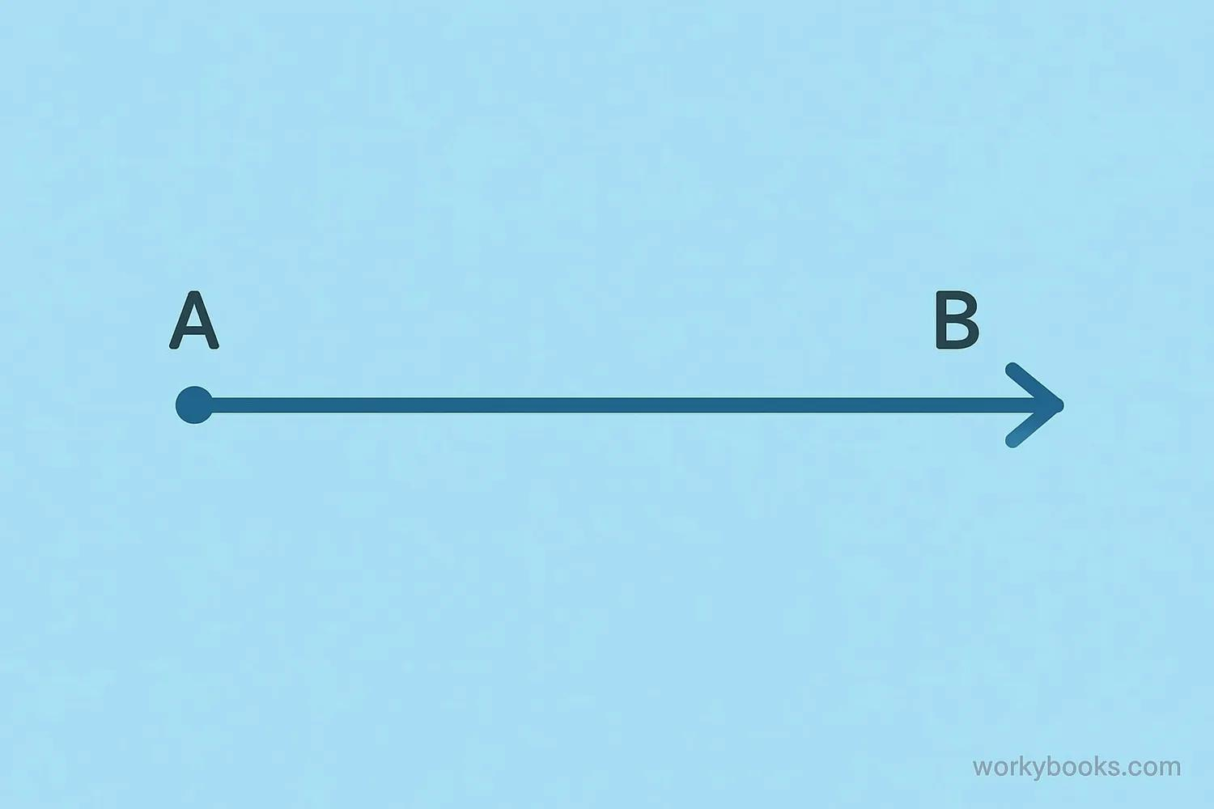
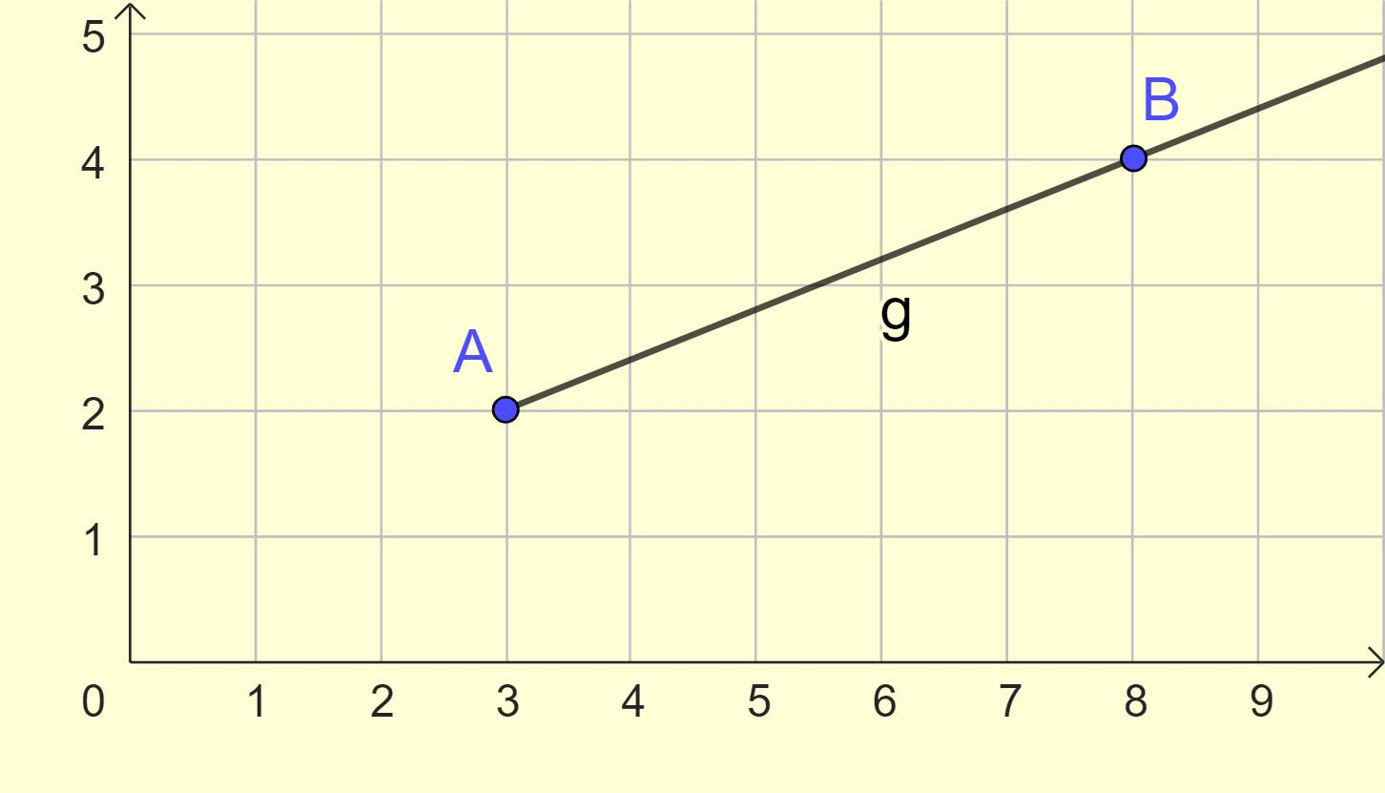
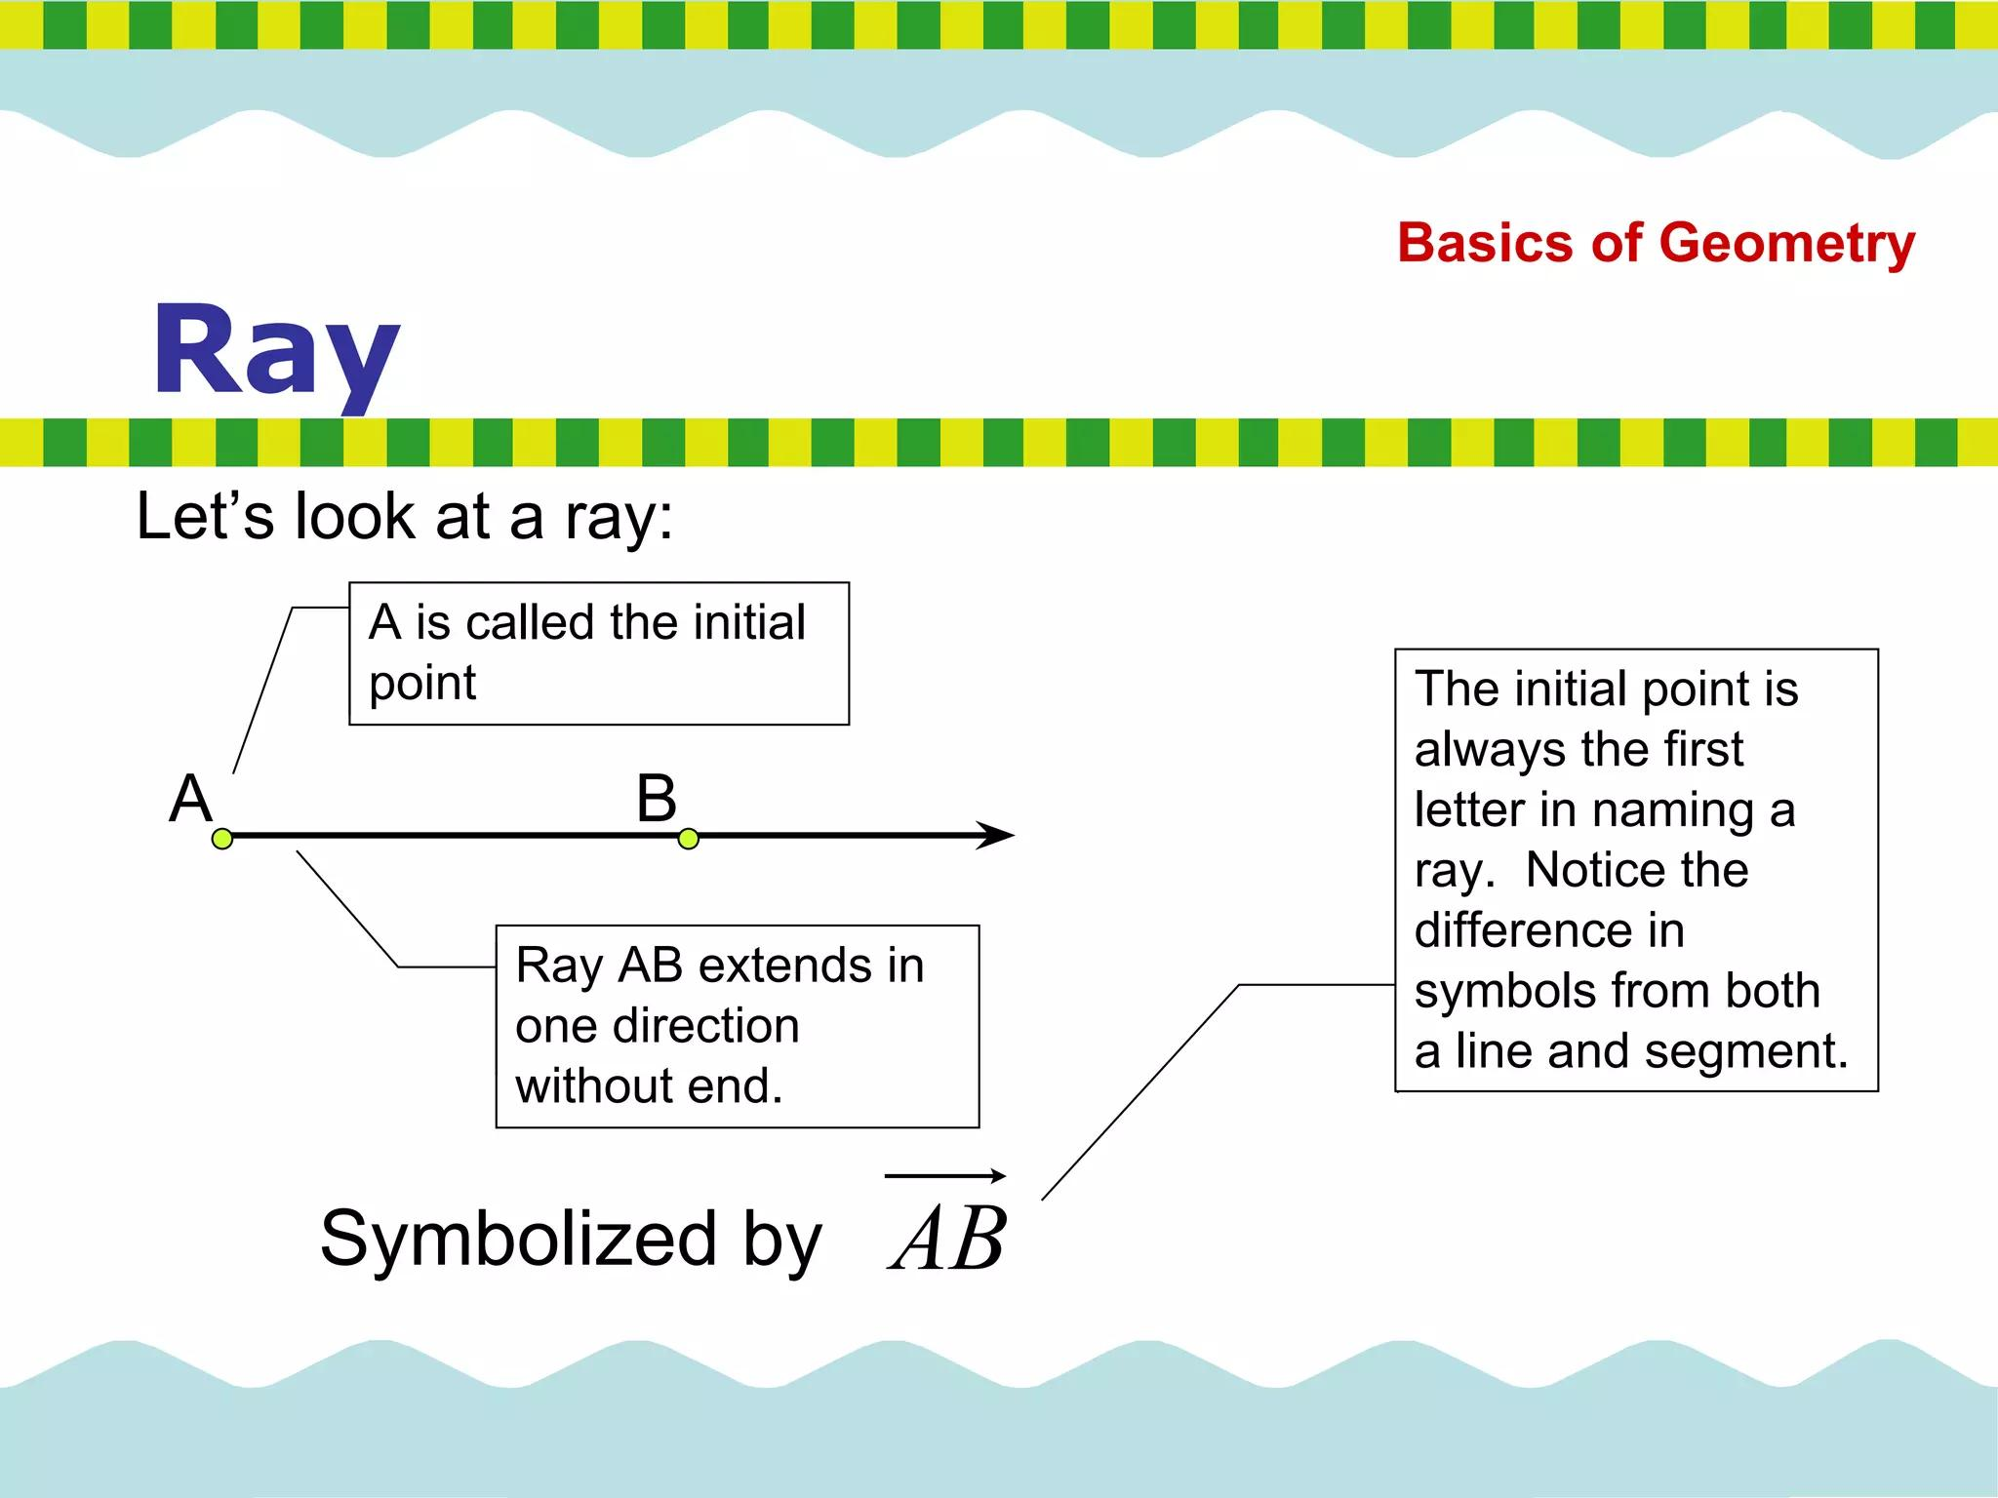
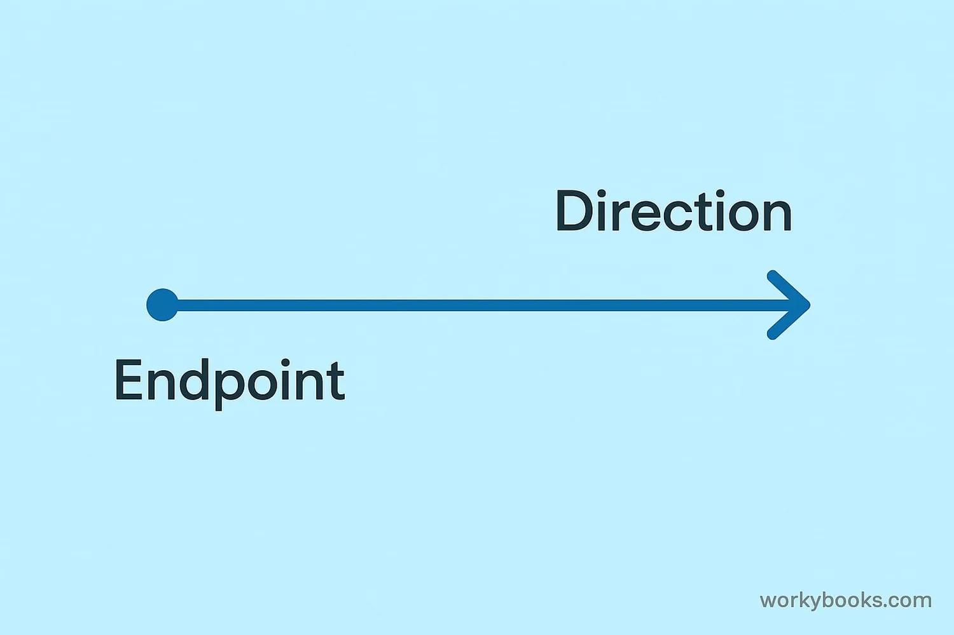
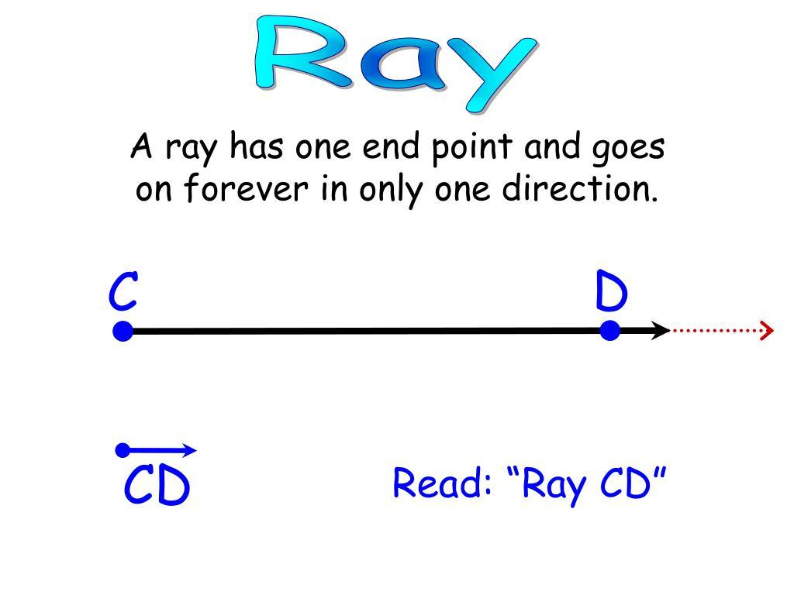

Definition
# Source: AI Source: Provided by: [Data Path: Persons Table -> ID Column: 1, Name_En Column: Motasem Essam] -> From: [ChatGPT] on [7/25/2026]
A Ray is a part of a line that has one endpoint and extends infinitely in one direction. It begins at a fixed point and continues forever without an ending point.
A ray combines the properties of a point (its starting point) and a line (its infinite extension).

Characteristics
# Source: AI Source: Provided by: [Data Path: Persons Table -> ID Column: 1, Name_En Column: Motasem Essam] -> From: [ChatGPT] on [7/25/2026]
A ray:
- Has one endpoint.
- Extends infinitely in one direction.
- Is perfectly straight.
- Has one dimension (length).
- Contains infinitely many points.
- Can be measured only from its endpoint to any chosen point, since its total length is infinite.

Illustration
# Source: AI Source: Provided by: [Data Path: Persons Table -> ID Column: 1, Name_En Column: Motasem Essam] -> From: [ChatGPT] on [7/25/2026]
A •──────────────• B──────────────→
- A is the endpoint.
- The ray passes through B and continues infinitely to the right.

Mathematical Representation
# Source: AI Source: Provided by: [Data Path: Persons Table -> ID Column: 1, Name_En Column: Motasem Essam] -> From: [ChatGPT] on [7/25/2026]
A ray starting at A and passing through B is written as:
$$\vec{AB}$$
where:
- $A$= endpoint (starting point)
- $B$= any other point on the ray that indicates its direction
Order matters:
$$\vec{AB}≠\vec{BA}$$
because they point in opposite directions.

Examples
# Source: AI Source: Provided by: [Data Path: Persons Table -> ID Column: 1, Name_En Column: Motasem Essam] -> From: [ChatGPT] on [7/25/2026]
Examples of rays include:
- A flashlight beam.
- A laser beam (idealized).
- A sunbeam.
- A road beginning at a city and extending in one direction.
- One side of an angle.

Types of Rays
# Source: AI Source: Provided by: [Data Path: Persons Table -> ID Column: 1, Name_En Column: Motasem Essam] -> From: [ChatGPT] on [7/25/2026]
Common types include:
- Horizontal Ray
- Vertical Ray
- Oblique (Diagonal) Ray
- Opposite Rays
- Angle Rays

Properties
# Source: AI Source: Provided by: [Data Path: Persons Table -> ID Column: 1, Name_En Column: Motasem Essam] -> From: [ChatGPT] on [7/25/2026]
A ray:
- Has exactly one endpoint.
- Extends infinitely in one direction.
- Contains infinitely many points.
- Has no ending point.
- Two opposite rays sharing the same endpoint form a straight line.

Opposite Rays
# Source: AI Source: Provided by: [Data Path: Persons Table -> ID Column: 1, Name_En Column: Motasem Essam] -> From: [ChatGPT] on [7/25/2026]
Two rays are opposite rays if:
- They have the same endpoint.
- They extend in opposite directions.
Example:
←────────────• A────────────→
The two rays share endpoint A and form a straight line.

Applications
# Source: AI Source: Provided by: [Data Path: Persons Table -> ID Column: 1, Name_En Column: Motasem Essam] -> From: [ChatGPT] on [7/25/2026]
Rays are used in:
- Plane Geometry
- Coordinate Geometry
- Angle Construction
- Engineering
- Architecture
- Construction
- CAD (Computer-Aided Design)
- Computer Graphics
- Robotics
- GIS (Geographic Information Systems)

Advantages
# Source: AI Source: Provided by: [Data Path: Persons Table -> ID Column: 1, Name_En Column: Motasem Essam] -> From: [ChatGPT] on [7/25/2026]
Studying rays helps to:
- Construct angles.
- Describe direction.
- Analyze geometric relationships.
- Support geometric proofs.
- Model directional paths.

Limitations
# Source: AI Source: Provided by: [Data Path: Persons Table -> ID Column: 1, Name_En Column: Motasem Essam] -> From: [ChatGPT] on [7/25/2026]
A ray:
- Has infinite length.
- Cannot represent a finite object by itself.
- Depends on its endpoint and direction.

Comparison with Related Objects
# Source: AI Source: Provided by: [Data Path: Persons Table -> ID Column: 1, Name_En Column: Motasem Essam] -> From: [ChatGPT] on [7/25/2026]
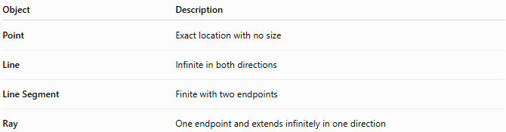
Object | Description
Point | Exact location with no size
Line | Infinite in both directions
Line Segment | Finite with two endpoints
Ray | One endpoint and extends infinitely in one direction

Key Points
# Source: AI Source: Provided by: [Data Path: Persons Table -> ID Column: 1, Name_En Column: Motasem Essam] -> From: [ChatGPT] on [7/25/2026]
- A Ray has one endpoint.
- It extends infinitely in one direction.
- It is represented by:
$$\vec{AB}$$
- The first letter represents the endpoint.
- Rays are fundamental for constructing angles and describing direction in geometry.

Conclusion
# Source: AI Source: Provided by: [Data Path: Persons Table -> ID Column: 1, Name_En Column: Motasem Essam] -> From: [ChatGPT] on [7/25/2026]
A Ray is a one-dimensional geometric object that begins at a fixed endpoint and extends infinitely in one direction. It is an essential building block of geometry, particularly in the construction of angles, directional relationships, and coordinate systems. Rays are widely used in plane geometry, coordinate geometry, engineering, architecture, construction, CAD, robotics, GIS, navigation, and computer graphics, where representing direction from a fixed starting point is fundamental to geometric modeling and spatial analysis.

